**Object Oriented Programming – Lab 1**

**Instructor –** Abdullah Yaqoob

**Name:** Meher Ali **-- Class:** BCS-3A **-- Roll no**: 24K-0545

**Task#01**

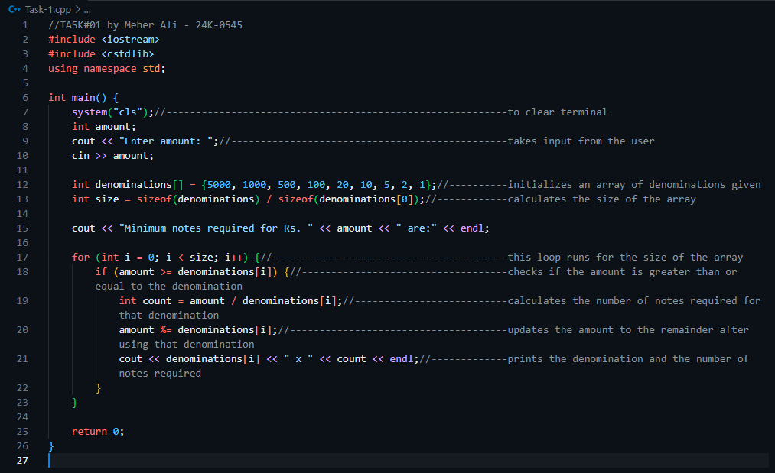**Source Code:**

**Output:**

**Task#02**

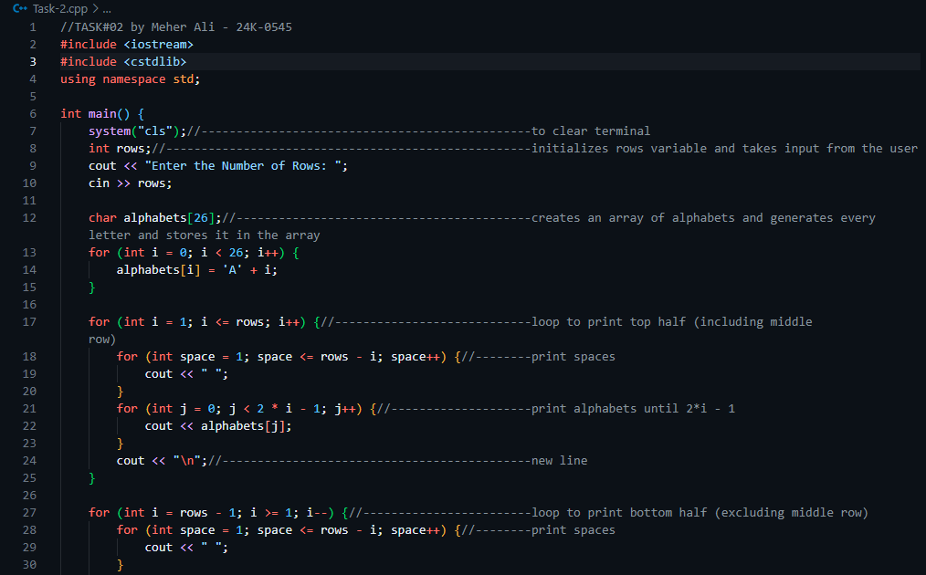**Source Code:**

**Output:**

**TASK#03**

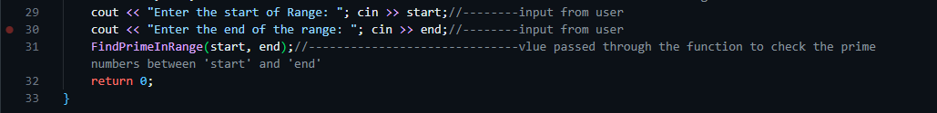**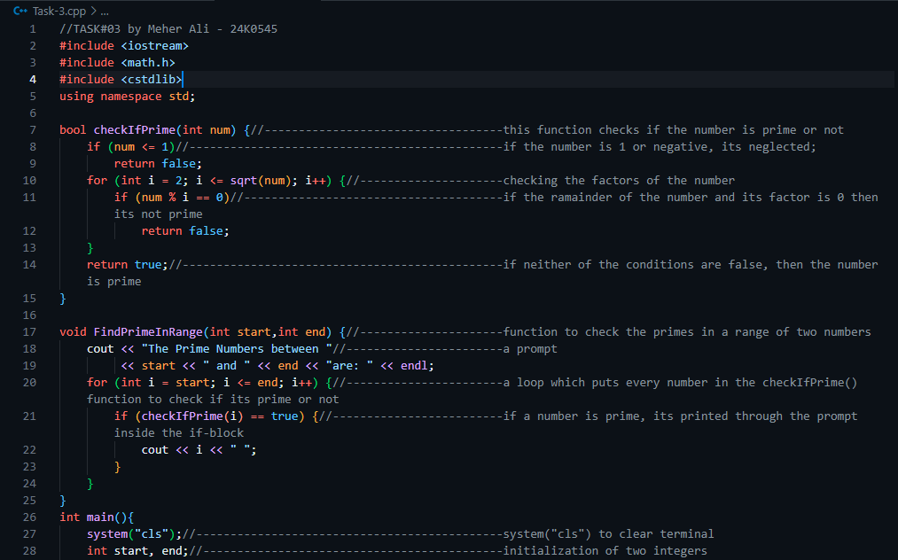Source Code:**

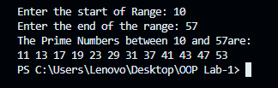**Ouptut:**

**TASK#04**

**Continue…**

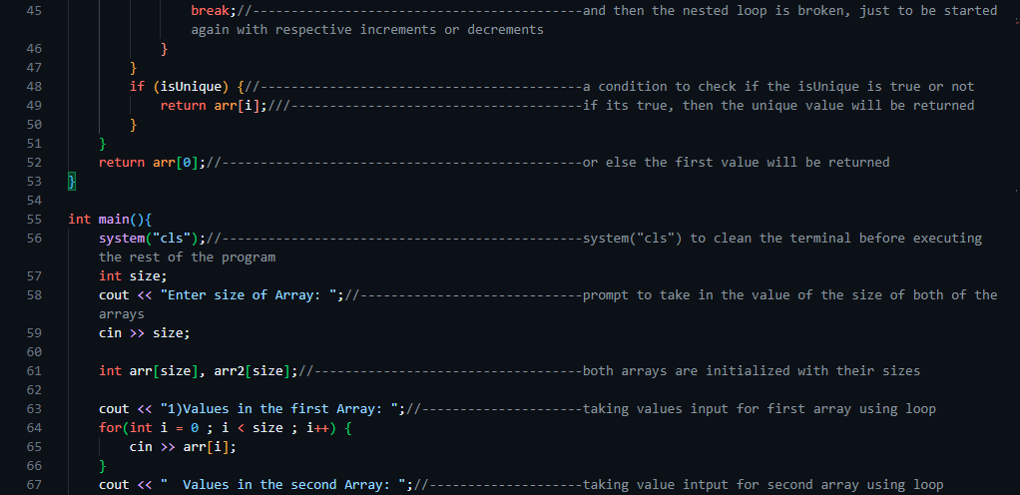**.**

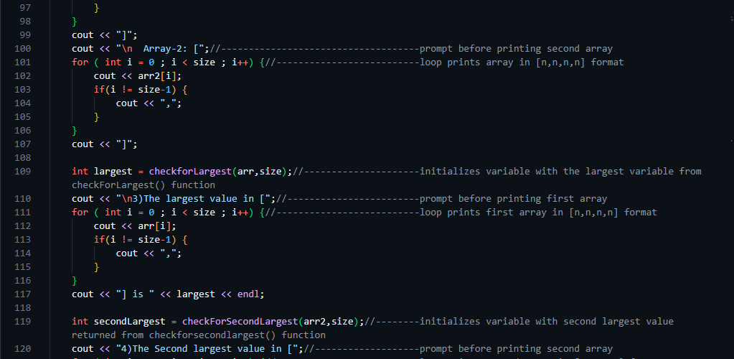**.**

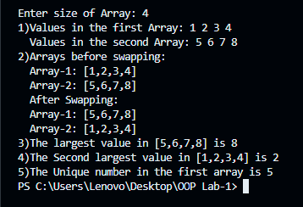**Output:**

**TASK#05**

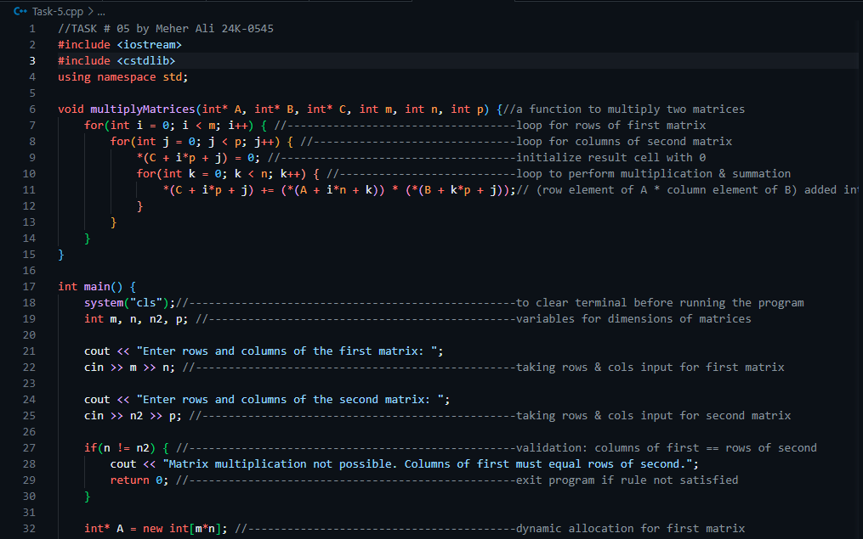**Source Code:**

**.**

**continued….**

**Output:**